Maximo Antigua

CST 2309 Lab 3.2

Refer to Tutorial 2: Create a Website for a Fitness Club

1. Complete Session 2.2 from pages HTML 110 to HTML 133

Add a screenshot of the **tss_home.html** file displayed in a browser after completing Step 3 on page HTML 132. Include the address bar in the screenshot. See Figure 2-30 for reference.

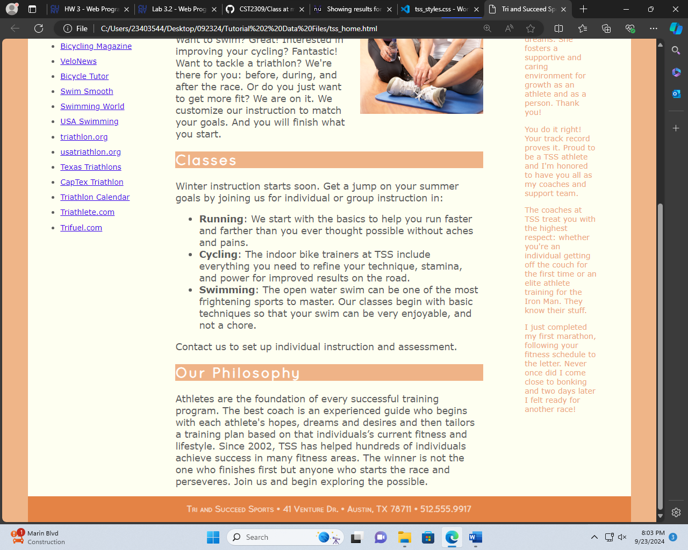

1. Complete the Session 2.2 Quick Check in Blackboard